Press release

Paris, 12 January 2021

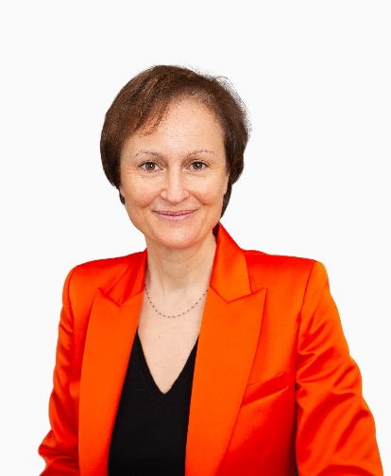
Delphine Asseraf appointed Deputy CEO of holding company comprising Harvest and Fidroit.

Delphine Asseraf has been appointed Deputy CEO and member of the management committee of the holding company comprising Harvest and Fidroit, majority-owned by the Five Arrows fund and the Rothschild & Co group.

With an accomplished career history in digital technology, banking and insurance, Delphine Asseraf will be responsible for coordinating the holding company’s international strategy and enhancing the customer experience across all wealth management and asset management professions. She will also take charge of the marketing, communication, CSR and product strategy department.

An engineering graduate from the Ecole supérieure d’ingénieurs en génie électrique, Delphine Asseraf began her career at the BNP Paribas Group, with responsibility for Internet platforms. In 2011, she became BNP Paribas’ head of digital development for online banking, e-commerce and new payment methods. She then launched Hello Bank! in France and contributed to the creation of Paylib. In 2013, Delphine Asseraf joined the Allianz group to implement and oversee the digitalisation of Allianz France. In 2015, she was named digital personality of the year and young manager of the year. The following year, she became head of Allianz France’s Digital, Brand Management and Communications Department. In 2017, she was entrusted with creating the first Allianz ecosystem dedicated to Mobility and developed new ways of working. At global level, she headed the Allianz international ecosystem dedicated to the collaborative economy. In 2020, she joined the head office of the Allianz Group in Munich to take charge of digital marketing and distribution at global level.

About Harvest and Fidroit

In order to support all wealth management players at every stage of the financial advisory process, HARVEST and FIDROIT joined forces under the umbrella of a holding company on 16 December 2020 to offer “the best of both worlds” – digital and human, tools and services, financial and technological expertise, advisory services and transactions. With around 330 employees, the complementary skill sets of the two firms will allow for many synergies and an industrial strategy capable of meeting the transformation challenges the sector faces.
Founded over 30 years ago, HARVEST has been recognised as a Great Place to Work. It is a fintech specialising in the wealth management and finance sectors (#TechForFin). The company designs digital solutions for all players in the financial advisory process. For over 25 years, FIDROIT has been supporting wealth management professionals with their advisory activities. Its 45 specialists decipher, organise and make accessible the information required to make informed financial decisions.
Their combined know-how in highly specific areas allows them to meet the needs of financial and wealth management professionals and to consolidate and grow their business with over 4,000 clients (banks, insurance companies, management companies, financial advisers, platforms, family offices, accountants, tax lawyers, solicitors), through a range of professional software, training and support solutions highly popular among today's industry professionals.

Find out more: www.harvest.fr / www.fidroit.fr

MEDIA CONTACT:
Nathalie MARTIN SANCHEZ +33 (0)6 40 66 07 93
nathalie-martin-sanchez@harvest.fr

